A000-Eur-Italy-Roman-Bronze bust-Female-200 CE

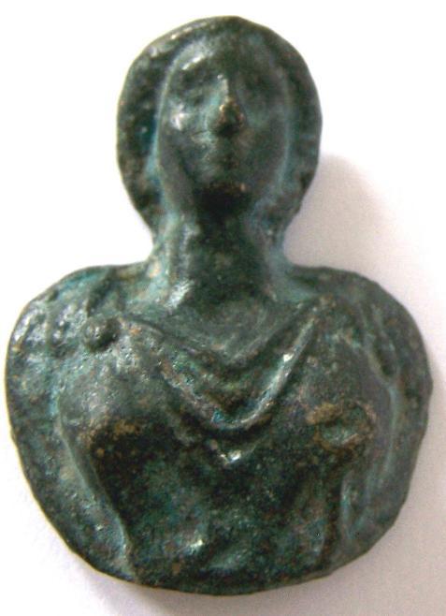

Case no.: 4

Accession Number:

Formal Label: Italy-Roman-Bronze bust-Female

**Display Description:**

**Medallions such bronze busts were popular as likenesses of family members and in addition as votive objects which soldiers would take on expeditions to remind them of their loved ones at home.**

**LC Classification: C135**

Date or Time Horizon: ca 200 CE

Geographical Area: Rome

**Map:**

**GPS coordinates:**

Cultural Affiliation: Roman Empire

Medium: bronze

Dimensions: 4 x 3 cm

Weight:

Condition:

Provenance: Old English collection

**Discussion:**

**References:** Baldwiin, Agnes. 1923. *Roman Bronze medallions*. Numismatic notes and monographs, 17.

|  |  |
| --- | --- |
|  | New York : American Numismatic Society |

.

|  |
| --- |
| **Payment details** |
|  |
|  |
| **Shipping details** |
| **Ralph J Coffman Jr**  149 Atlantic Ave  Swampscott MA 01907-2427  United States |

Order details

|  |  |  |  |
| --- | --- | --- | --- |
| **Item title** | **Available actions** | **Shipping & handling (estimated delivery*)** | **Price** |

|  |  |  |
| --- | --- | --- |
| Seller: | [**Member id** antiquewd](http://myworld.ebay.com/antiquewd) ( [**Feedback Score Of** 1433](http://feedback.ebay.com/ws/eBayISAPI.dll?ViewFeedback&userid=antiquewd)) | [Contact seller](http://contact.ebay.com/ws/eBayISAPI.dll?ShowCoreAskSellerQuestion&frm=3998&iid=0&redirect=0&requested=antiquewd) |

|  |  |  |  |  |
| --- | --- | --- | --- | --- |
| **Order # 123464626018**  Paid on Oct-28-12 via PayPal | | | | |
|  |  | |  | | --- | |  | | |  |  | | --- | --- | | [Contact seller](http://contact.ebay.com/ws/eBayISAPI.dll?ShowCoreAskSellerQuestion&frm=3998&iid=360501193298&redirect=0&requested=antiquewd) |  | | |  |  |

[Roman style bronze face**- opens in a new window or tab**](http://cgi.ebay.com/ws/eBayISAPI.dll?ViewItem&item=360501217436)

**Item Id:**360501217436 - Price: US $76.00

Quantity:1

Having a problem with this purchase? [We can help](javascript:;)

|  |
| --- |
|  |
| |  |  | | --- | --- | | [Leave feedback](http://feedback.ebay.com/ws/eBayISAPI.dll?LeaveFeedbackShow&useridfrom=802-867&useridto=antiquewd&item=360501217436&transactid=0) |  | |

Shipped with item above

**Package 1 of 1**



Shipment details: [9410809699937262021869](javascript:;)

US $76.00